**Exercise 1: Horizontal menu in the homepage**

**Exercise 2: View show the list book from the category book**

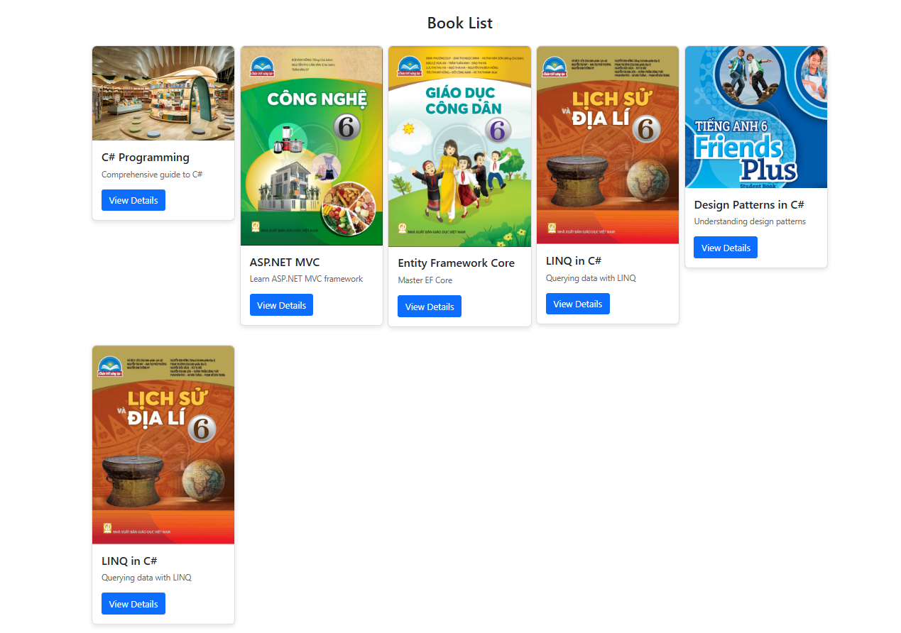

**Exercise 3: Detail information of book**

**Exercise 4: Loading and Displaying PDFs for Books**

